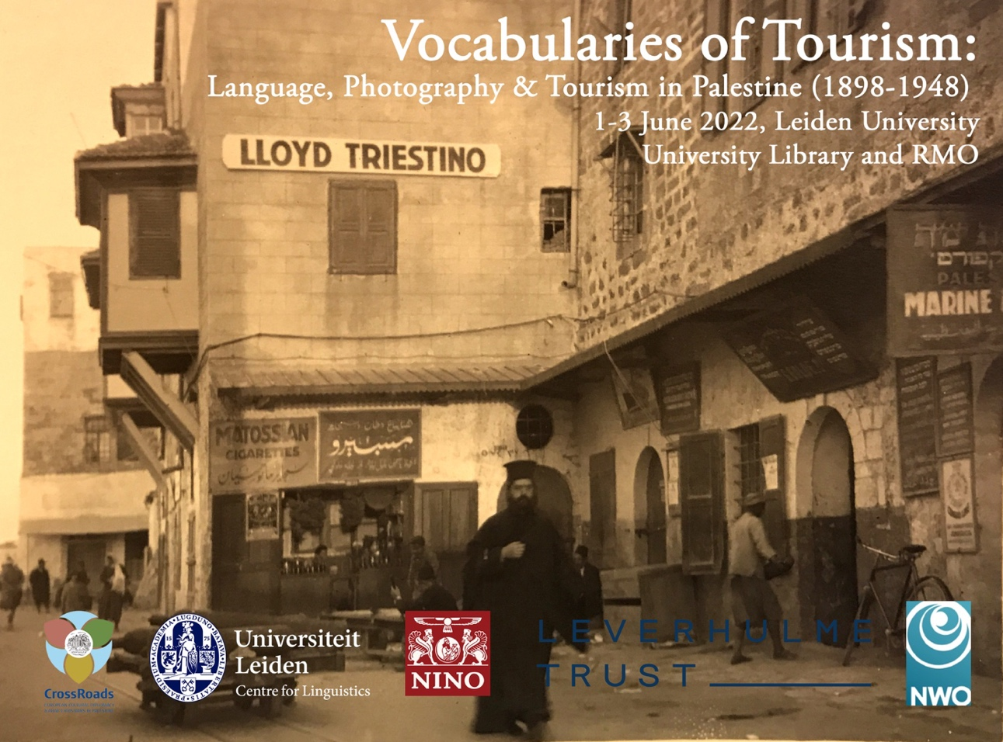

A workshop and special issue investigating 50 years of language, tourism and social history in Ottoman and British Mandate Palestine

Program
Discussions not open to the public on:
Wednesday 16:00-18:00; Thursday 9:30-13:00; Friday 9:30- 13:00

+ 2 public events

1/6 Hensius room and 2-3/06/2022 Vossius room, University Library
2-3/06/2022 afternoons at RMO (Museum of Antiquities)

Format: 25 min presentation + 25 min discussion
Publication: Mashriq & Mahjar (Proposal & planning accepted)

Hotel: De Doelen, Rapenburg 2, 2311 EV Leiden, https://dedoelen.com

This conference considers vocabularies of tourism, in broad terms, to think about the ways in which Palestine was both produced and consumed by Arab, and European and other visitors. Focusing broadly from questions of multilingualism, especially in tourist guides and language manuals, to the ways in which photography and its increasing availability were shaped by the demands of tourism markets, Vocabularies of Tourism also considers the relationship between tourism and cultural diplomacy. This aspect will focus on Arab cultural production, both textual and image-based, but also the ways in which this may have formed as a response to Western scholarly interests in the region, particularly fields like archaeology, which had become increasingly entwined with both Western diplomatic aspirations in the Levant but had also been incorporated into the circuits of popular tourism. In this respect, the biblical overtones of ‘Holy Land’ tourism are both a product of modernity (especially the technological infrastructures that enabled it), but also a projection into an ancient past that undermines such modernity.

Alphabetical order

Felicity Cobbing (PEF) execsec@pef.org.uk
Connections, Connections - The Palestine Exploration Fund as an ‘Influencer’ of Western ideas of the Levant

As the first western institution of its kind, the Palestine Exploration Fund enjoyed a degree of influence which belied its modest size and empty coffers. Indeed, the interest of the wider public in its work was essential to sustaining an income stream capable of supporting its work, so the PEF invested significantly in the development of various tactics and products with which to entice a mainstream audience. Some of these were successful, some less so. This talk will explore the various tools which the PEF developed to engaged with its audience from the mid 19th century to the present day, to sustain this role as an ‘influencer’ in the West’s ideas of the Levant, from enjoying the ear of policy makers to enthusing the non-specialist wider public about its work.. The PEF has always walked a tightrope between populism and academia, a challenge which is difficult to pull off at the best of times, but with huge political and ideological interests at work in the region, this aim is sometimes impossible to achieve. The changing fortunes of Palestine in the 20th century, and the changing demographics in the Middle East and in the UK have all had their challenges and opportunities to the organisation, and the present day clearly is no different.

Keywords: Palestine, archaeology, biblical studies, tourism, photography

Biography
Felicity Cobbing is the Chief Executive and Curator of the Palestine Exploration Fund, where she has worked for over 20 years; she has gained an expertise in the role the organisation has played in the development of archaeology and related subjects in the study of the Levant. Trained as an archaeologist specialising in the Bronze and Iron Ages of the southern Levant, she has excavated in Jordan and worked all over the Levant. She leads specialist tours to the region for Martin Randall Travel (MRT), and lectures in the UK and abroad. She has co-authored several books for the specialist and wider audience, including ‘Beyond the River: Ottoman Transjordan in Original Photographs’ (Stacey International 2006 ), and ‘The Photographs of the American Palestine Exploration Society’ (AASOR Vol 66, 2012) as well as numerous articles on the role of the PEF in the development of the study of the ancient Levant.

Jasmin Daam jasmin.daam@gmx.de
The authenticity trap: Co-produced narratives in tourism to Mandate Palestine

During the 1920s and 1930s, local actors in the Eastern Arab Mediterranean encouraged tourism not only in order to foster economic growth but also to articulate political claims. Particularly in the countries under imperial rule, tourist mobility created a space of communication which allowed intellectuals, entrepreneurs and interest groups to present their demands for sovereignty to mostly European tourists. Yet, while local associations in Lebanon and Egypt actively promoted the modernity of their emerging nations, Palestinian actors rather highlighted historical continuities, multi-religious coexistence and local traditions. Building on Nikolas Glover’s notion of “co-produced histories”, I understand these narratives of Palestinian guidebook authors and tour guides – and their failure – as a result of the specific dynamics between competing actors in tourism to Mandate Palestine.
Based on an analysis of brochures, postcards, as well as travel diaries of tourists, I argue that the (mostly Christian) Palestinian actors in tourism emphasized historical continuities and traditions in order to falsify Zionist allegations of an “empty” Palestine. However, this narrative of authenticity failed to convince European tourists of the legitimacy of Palestinian claims not only because of inadequate strategies of communication (the comprehensive communication strategy of Zionist associations remained largely unanswered by Palestinian actors), but also due to a problem inherent in the narrative of authenticity. I suggest that the dominant presence of Zionist modernity pushed the Palestinian actors into adopting narratives of authenticity and tradition, which, from the point of view of the tourist audience, ultimately relegated Palestinian claims to the past.

Keywords: tourism; Palestine; Mandate; nationalism; historical narratives

Biography
Jasmin Daam studied history and French and Italian literature and linguistics at the University of Konstanz and the Université Paris I Panthéon-Sorbonne. In 2015, she joined the University of Kassel as research and teaching assistant in the field of global history and the history of globalization processes. Her main research interests concern colonial and global history, the history of the modern Middle East and North Africa, as well as cultural history with a particular focus on the history of travel and tourism. As a member of the “Modern Mediterranean” research network funded by the German National Research Association (DFG), she co-organised a conference in Beirut in October 2019 on the topic “Questioning the Mediterranean: (Self-)Representations from the Southern Shore” (with Esther Möller).
Jasmin Daam is currently engaged in a Ph.D. project on “Tourist spaces: The Arab Eastern Mediterranean as a tourist destination in 1920s and 1930s”, which has been supported by research grants from the Studienstiftung des deutschen Volkes, the German Historical Institute in Paris and the German Historical Institute in London. The project aims to explore how tourism both reflected and shaped the spatial order of the Arab Eastern Mediterranean after World War I. The contributions of the Mandate powers, national movements, local intellectuals and entrepreneurs, and tourists themselves are examined on the basis of a variety of source material, both textual and visual.

Chloe Emmott c.m.emmott@gre.ac.uk
Intersections of archaeology and tourism in Late Ottoman and British Mandate Palestine

The boom in Biblical archaeology and tourism in Palestine were largely contemporaneous and archaeology often acted as a magnet for tourists, attracting interested visitors to the Holy land, and even to excavations in progress, often to the chagrin of archaeologists. During the Mandate era, the British mandate government worked hard to establish control over antiquities and developed the Palestine Archaeological Museum out of its Ottoman predecessor, as well as making plans to integrate archaeological sites as tourist attractions.
I explore how the growth in tourism and archaeology was spurred on in part by the press and the ever-growing market for travel books, both personal memoirs and practical guidebooks; as author Robert Curzon remarked it was a market ‘overwhelmed with little volumes about palm trees and camels’. It was a period of change, with the end of centuries of Ottoman rule, and the development of new technology enabling easier access for tourists and easier mass distributions of printed and photographic material.
I explore how archaeology and tourism helped to form an ‘imagined landscape’ of Palestine in the British cultural imagination. In particular I explore how the past of Palestine, through the rapid growth of archaeology as a discipline, was used to justify the present and how this informed the ‘world as an exhibition’ view of Palestine, and the Palestinians, who this process left silenced and othered.

Keywords: Archaeology, tourism, travel, photography, imagery

Biography
Chloe Emmott is a PhD student at the university of Greenwich, researching the history of British archaeology in Palestine. She completed her BA in archaeology of Ancient Civilisations at the University of Liverpool. After graduating she completed a social history project on Liverpool’s Chinatown and docks and the Church of St Michaels. She returned to the University of Liverpool to study her MA in archaeology, focusing on the history of excavations in Jericho. She is interested in the history of archaeology in the Middle East, particularly Palestine, Biblical Archaeology and the political uses of heritage.

Sarah Irving sarahirvingwork@gmail.com
‘Indian Lady Tourists Killed at Jericho’: tourism, pilgrimage and south-south relations in interwar Palestine

In press coverage of the 1927 earthquake in Palestine, one of the most frequently mentioned items was the death of three women when the foyer of the Winter Palace Hotel in Jericho collapsed. The fact that the three were from India, then a colony of the British Empire, apparently rendered them sufficiently unusual to be of note to a press agency journalist whose observation was reproduced around the world. This article draws on press reports, official papers and secondary literatures on the hajj, tourism and the British Empire to consider the role of ‘south-south’ travellers to Palestine and the relationships between colonialism and travel in the interwar period.
One of the three women was Lady Abdul Rauf, the wife of a retired judge from the High Court of Allahabad and veteran Indian Muslim nationalist campaigner, Sir Syed Abdul Rauf. The couple had departed Bombay on 26th April 1927 along with over 1,400 other Indians making the hajj journey to Mecca and Medina, but before returning home extended their trip to include Jericho. This in itself was not unusual; the 700-year-old Indian Hospice in the Old City of Jerusalem attests to the long history of Indian visitors to Palestine. This paper, however, locates the ill-fated presence of Lady Abdul Rauf and her two companions in the changing nature of Indian travel in the region, as religious pilgrimage to Jerusalem combined with political and touristic motivations and as the changing infrastructures of capitalism and colonialism shifted the ways in which Indian visitors experienced Palestine

Keywords: British Empire, hajj, India, Muslim, tourism, Palestine

Biography
Sarah Irving is a Leverhulme early career research fellow at Edge Hill University and Editor-in-Chief of Contemporary Levant (CBRL). She was awarded her PhD from the University of Edinburgh at the beginning of 2018 and has taught at King’s College London and Edge Hill and Linnaeus Universities. She is the author of a number of scholarly articles on the uses and operation of history and archaeology in Late Ottoman and Mandate Palestine and on contemporary Arabic literature, and prior to her return to academia also authored a number of books on Palestine.

Rachel Mairs ‎r.mairs@reading.ac.uk
'Teach Yourself Arabic!': Colloquial Arabic through Phrasebooks, 1798-1945

Drawing upon my current British Academy project, this paper explores how the Arabic language was taught to and learnt by speakers of other languages outside formal educational contexts in the period between the Expedition of Napoleon and the Second World War. Phrasebooks and vocabularies are an under-utilised resource in both historical sociolinguistics and social history. They provide an opportunity to look at how travellers without a traditional European Orientalist education engaged - or failed to engage - with the Arabic language and the Middle East. They also provide an insight into how Arabs sought to present their language to foreigners. I will review a selection of phrasebooks for speakers of English, French, German, Russian, Yiddish and Hebrew for use in Palestine, and discuss what these tell us about the language-learning strategies of both students and teachers, and the impact this had on relations between Palestinians and foreigners.

Keywords: phrasebooks, Arabic, language-learning, tourism, First World War

Biography
Rachel Mairs is Professor of Classics and Middle Eastern Studies at the University of Reading. She has previously held positions at New York University, the University of Oxford and Brown University. Her research focusses on ethnicity and multilingualism in Hellenistic Egypt and Central Asia. She has also published on the colonial history of archaeology in the Middle East. Her publications include The Hellenistic Far East: Archaeology, Language and Identity in Greek Central Asia (2014), Archaeologists, Tourists, Interpreters (with Maya Muratov, 2015) and From Khartoum to Jerusalem: The Dragoman Solomon Negima and his Clients (2016). She currently holds a British Academy Mid-Career Fellowship for the project 'Teach Yourself Arabic: Foreigners Learning Colloquial Arabic 1798-1945'.

Karène Sanchez Summerer & Clementine Rubio clementine.rubio@gmail.com
Private and official dragomans for French in Palestine. Cultural interface, Image of the Promised Land and loyalty (1880-1920)

At the end of the XIXth century, when France envisaged a long-lasting sovereignty in the region, French officials and French tourists considered the Maronites as their natural allies, but also as a channel of French influence. Maronites played a central role as private and official dragomans, as tourist agents, translators and cultural interfaces for French actors (diplomats, tourists, pilgrims) in Palestine, as part of Greater Syria.
This paper will draw a portrait of some of these "dragomans", reconsidering their role, personal trajectories, and ties with the French administration and with French tourists and pilgrims. It will examine their role as intercultural agents via the prism of loyalty. Based on diplomatic archives from the French consulate in Jerusalem, tourist guides and travellers’ memoirs, this paper will also examine the tourist itineraries and the image of Palestine as part of Greater Syria through the lenses of both the relation between France and the so-called Holy Land and interregional contacts

Key words: Palestine, dragomans, tourism, French consulate in Jerusalem

Biography
Clémentine Rubio was an Aspasia project fellow at Leiden University (February-May 2020), and Research Associate at the University of Tours, at Paris 3-Sorbonne Nouvelle University and the French Research Centre in Jerusalem. She completed a PhD at Tours University in June 2018, focusing on the history of French language teaching in Palestine. Her research interests include the question of language spread, linguistic diplomacy, and language identity. More recently, she focuses on the question of archives in the study of language spread and on the role of women in the history of language teaching.

Micaela Sahhar micaelasahhar@yahoo.com.au
‘Behold the Promised Land’: Christian-Palestinian entrepreneurs in Mandate tourism

This paper investigates Christian Palestinian involvement in tourism, and Western Pilgrimage, in Mandate Palestine, particularly the tension between political fidelity and mercantile aspirations. It examines two 1930s travel pamphlets, published in English and co-authored by a Greek-Orthodox Jerusalemite, George M. Sahhar (1901-1976). Sahhar’s tourism enterprises in Jerusalem catered to an English-speaking British and American clientele, some associated with the British-Israelite movement. These guides indicate Western appetite for biblical and pseudo-historical narratives of Jewish connections to Palestine, later deployed in Israeli national narratives.
Traveller’s Notebook for Palestine (1931), presents a geography overshadowed by scripture, explicitly declaimed in the foreword: ‘the presence of the Saviour is felt at every turning’. Twentieth century Palestine is made significant through biblification, a rationale that also determines the selection of entries. For example, Nazareth ‘owes all its celebrity’ to Jesus Christ, and, in the estimation of the authors, remained undistinguished in the 20th century.
The Traveller’s Companion to the Holy Land (1935), meanwhile, reveals in its text and advertising the nuanced connections between Christian-Palestinian tour operators and commercial markets in Jerusalem. The guide offers details of Jewish antiquity and the 20th century political forces that resulted in the creation of Israel thirteen years later, including remarks on the Balfour Declaration and activities of the Jewish National Fund.
Both guides offer insight into Christian tour operators and the tastes of their clientele. Together, they indicate the ambivalent instrumentality of Christian Palestinian entrepreneurs in biblifying Palestine for the Western imaginary, a strategy now implicated in normalizing Israel’s creation in 1948.

Key words: Biblification, Christian-Palestinians, Narrative appropriation, Mandate tourism, Western imaginary

Biography
Micaela Sahhar is an Australian-Palestinian researcher, educator and poet. She lectures at Trinity College in Melbourne in the History of Ideas program where she has worked towards decolonizing the curriculum. Her doctoral project focused on Israeli national narrative and Western media coverage in the 21stcentury. This work was particularly concerned with media coverage of Israeli military incursions in Palestinian territory, the elision of Palestinian narrative, and the possibilities of its recuperation. Micaela has had articles published on comparative Israeli and Australian settler-identities, settler-state treatment of its others, and contemporary resistance strategies in Palestine in edited books and Australian and international journals. Her poetry has been published in The Age, Southerly and Arena Magazine and her commentary pieces on Israel/Palestine have appeared in online journals, Overland and Arena. Her current research interests include comparative settler colonialism and narrative appropriation, identity and indigeneity, and the question of resistance in settler-colonial societies.

Ian Simpson i.r.simpson@arch.leidenuniv.nl
Castles, tombs and shrines: Islamic itineraries in Palestine

This paper explores Muslim religious visitation and tourism and the role of Islamic historical sites in Arab and British guides, photography and archaeology during Mandate Palestine. While biblical itineraries have usually dominated tourism and tourism studies in Palestine, Muslim historical sites also featured in British and Arab cultural production in the late nineteenth and early twentieth century. The paper focuses on castles, tombs and shrines relating to Islamic history as sites of tourism and visitation, and how they circulated in guides, postcards and photography. It will trace the British and Arab interests in promoting these sites and ask how early touristic languages relating to these Muslim sites shaped the image of Palestine from different perspectives.

Biography
Ian R Simpson is Assistant Professor in Heritage Practices in the Faculty of Archaeology at Leiden University. His work examines heritage practices in society from critical and anthropological perspectives, including the demands and expectations of heritage in environmental, community and memory projects. His research also investigates relationships between religion, environment, materiality and market exchange in early Islamic and medieval history, based on field research in Jordan and the Arab Gulf States.

Salim Tamari stamari@palestine-studies.org (online)
Spring ceremonials of Simon the Just and the syncretic religious festivals of Arab Jews, based on the newly released photographic collection of the National Geographic

Abstract tba

Biography
Professor of Sociology (Emeritus), Birzeit University; Research Associate, Institute for Palestine Studies; Editor, The Jerusalem Quarterly.
Recent Publications: Mountain Against the Sea: A Conflicted Modernity; The Storyteller of Jerusalem: The Life and Times of Wasif Jawhariyyeh (with Issam Nassar); Year of the Locust: Erasure of the Ottoman Era in Palestine; The Great War and the Remaking of Palestine (2018: UC Press); Landed Property and Public Endowments in Jerusalem (with Munir Fakhr Ed Din, 2018); Camera Palestina: Photography and the Sensual Impulse (UC Press; forthcoming 2021).

Annalaura Turiano annalauraturiano@gmail.com
Investigating the role of an Italian non-state actor in cultural diplomacy and tourism promotion in Palestine: the ANSMI’s written and photographic archives (1900-1948)

The Associazione Nazionale per Soccorrere i Missionari Italiani was founded in 1887 in Florence by the famous Italian archaeologist Ernesto Schiaparelli (1856-1928). In helping missionaries to found schools, hospitals and other humanitarian buildings in North Africa and the Middle East, the association pursued a twofold aim: to spread the Italian language and culture on the one hand; and to strengthen the Catholic presence in the Mediterranean basin on the other hand. Later on the association’s building activity increased and expanded to include the construction of hotels and sports centres. Between 1890 and 1940, “the ANSMI was the most important promoter of Italian building activity in the Middle East and North Africa” (Nuzzacci, 2012).
Although Arab Ottoman provinces were from its inception on the ANSMI’s agenda, its presence in Ottoman and later mandatory Palestine has not been sufficiently studied. Along with the construction and the renovation of missionary schools, orphanages and hospitals, the association purchased lands in order to build agricultural colonies and a hospice for pilgrims. The sanctuary of the Mount of the Beatitudes was among its largest constructions in the late 1930s.
This paper aims first to present the ANSMI’s untapped archives and their potential for the study of foreign cultural policies and humanitarian diplomacy in Palestine. Second, drawing on a rich photographic and written material, it intends to show how imperial aims, humanitarian concerns, and tourism promotion initiatives were intertwined in the association’s activities in Palestine during the first half of the 20th century. Ultimately, it sheds light on an Italian non-state actor’s contribution to both cultural diplomacy in Palestine and the “invention of the Holy Land” which resulted among other things in the mapping of new pilgrimage routes.

Key words: Palestine, ANSMI, archives, cultural diplomacy, tourism promotion

Biography
Annalaura Turiano is a research fellow in modern history at the École française de Rome. She is also associated with the Institute of Research and Studies on the Arab and Muslim World (IREMAM) in Aix-en-Provence. She holds a PhD from the University of Aix-Marseille (2016). Her first monograph (forthcoming) is based on her PhD dissertation and deals with the Italian Salesian missionaries in Egypt between 1890 and 1970.
Her specialisation is in the modern history of Italy, the Mediterranean and the Middle East. She focuses on imperialism, gender, missionary education and philanthropy in the 19th and 20th centuries. Her current project investigates the role of Italian female missionaries in the Eastern Mediterranean (notably Egypt and Syria) both in a period of high imperialism and of imperial transition. With respect to these topics, she has participated in several international conferences and workshops and published numerous articles and book chapters. She co-edited the book Le Moyen-Orient de 1876 à 1980, Paris, Éditions Atlande, 2017. Her recent publications focus on missionaries, gender and education in contemporary Egypt. Between 2008 and 2016, she worked as a teaching assistant and lecturer at the University of Aix Marseille and at the National Institute for Oriental languages and cultures in Paris. She has been the recipient of several grants and scholarships from international research institutes and universities. In the past ten years, she has conducted extensive fieldwork and archival research in Italy, Egypt, France and the United Kingdom.

Yair Wallach yw11@soas.ac.uk
Tourist, Pilgrim, Migrant, Settler: Rethinking the modern history of Ashkenazim in the Levant through sites of hospitality
In the gateway to the narrow valley ascending to Jerusalem, known as "Bab al-Wad", "the valley's door", stands an Ottoman caravanserai. Around it, arranged in a visible way, the remains of armoured vehicles, used by the Hagana in 1948 to deliver supplies to Jerusalem. This is a site of collective Israeli memory, perhaps one of the most identified with the Israeli narrative of the 1948 war. It is a narrative of conflict and conquest, in which Israeli liberation and independence, as a modern, European-styled state was achieved through overcoming the Oriental past, symbolised by the ancient caravanserai.
And yet the caravanserai, which in fact is not so ancient (constructed in the 1870s), offers a very different history of Jewish presence in modern Palestine, and specifically, Jewish European presence. Because this caravanserai, which was a key stopping point for carriages between Jaffa and Jerusalem, was operated by Ashkenazi Jewish families throughout much of the late Ottoman period. These Ashkenazi families, such as Salant, Rokach, and Rosenthal, arrived in Palestine in the early 1800s from Eastern Europe, and became tax collectors, merchants, and entrepreneurs. They were entrusted by the Ottoman Governor with charging the road tax from travellers. Rather than the familiar story of conflict and occupation, Bab al-Wad suggests an unfamiliar story of remarkably rapid integration of Jewish Ashkenazi migrants in the Arab Ottoman society and political structures.
In my talk I will look at Ashkenazi-operated hotels in Tiberias, Beirut, Jerusalem, Jaffa, Cairo and Alexandria and elsewhere, to consider the confusing ambiguities that these stories open up. Ashkenazi presence in Palestine is typically understood in terms of either the pious, zealot pilgrims or the nationalist settlers. And yet the story of the hotel owners and operators suggests a different category, that of migrants, who sought to integrate within existing social, economic and political structures. The tourism and hospitality industry, which relied on flow of people across borders, and on customers of various background, was to some degree at odds with the segregation associated with Zionist Yishuv. Such stories have been forgotten and erased by the history of Palestine in the 20th century, but prompt us to rethink our understanding of Ashkenazi history in the region. What was defeated in Bab al-Wad, is not only the Palestinian villagers of the Jerusalem Mountain, but also the very real historical possibility of Jewish Ashkenazi integration in the region.

Key words:

Biography
Yair Wallach is a senior lecturer in Israeli Studies at SOAS, the University of London, where he is also the head of the SOAS Centre for Jewish Studies. His research deals with the social and cultural history of modern Palestine/Israel, focussing on visual and material culture and the urban sphere. He has published articles on the use of maps and banknotes as symbols, on the sociology of late Ottoman Palestine's Jewish communities, on "shared space" in Jerusalem before 1948, and on Arabic and Hebrew street texts in early 20th century Jerusalem. His book, A City in Fragments: Urban Text in Modern Jerusalem (Stanford University Press, 2020) analyses the transformation of Jerusalem's textual landscapes - stone inscriptions, graffiti, street name plates and other forms in Arabic and Hebrew, from the mid 19th century to 1948.

Sary Zananiri, sary.zan@gmail.com
Imaging Histories: Marketing Scholarly and Public Photography at the Palestine Archaeological Museum
In 1938, the Palestine Archaeological Museum (PAM) moved into a new, purpose-built space. It’s remit included being both a research institution within Palestine’s archaeological networks and a hub for the public exhibition and dissemination of scholarly findings particularly amongst the building of a tourism industry. Analysis of photographs produced by PAM shows the Museum had a multipronged approach to medium, informing its various modes of public engagement as a museum.
This paper looks at the ways photography was employed for both popular lay consumption (such as postcards and marketing materials) and scholarly imaging (such as documentation of archaeological finds, conservation and illustration accompanying scholarly and semi-scholarly publications). In situating the role of photographic production, this paper will consider the interaction between these two strands of photography, and how they addressed and marketed the museum to a broad series of publics as part of an elucidation of PAM’s public outreach.
It asks a series of questions such as: how did the scientific photography and its use in scholarly and semi-scholarly publications influence the reputation of the museum abroad? What impacts did scholarly photography have on the production of popular imaging in the form of postcards and other ephemera? Are there overlaps in how the museum marketed its research in more scholarly circles and to the lay general public? What differences can we detect in the employment of photography as part of different strategies of engagement?
In doing so, it will contextualise these multifarious photographies particularly the legitimation of more popular materials by scholarly tropes of photography, while considering how the role of more public photography contributed to the continuation of support for PAM’s scholarly endeavours.
It will examine how photographers, such as JH Iliffe, Keeper of the PAM, and the brothers Najib and Jamal Albina, in the context of PAM’s formal engagement, but also in less formal contexts such as Iliffe’s engagement amateur photo competitions and the Albina’s commercial souvenir work outside the Museum.
This paper will primarily analyse materials from the Iliffe Collection at the University of Queensland and the newly acquired Pearlmann Collection at the Hebrew University.

CROSSROADS TEAM for this event:
Karène Sanchez Summerer, Associate Professor, K.Sanchez@hum.leidenuniv.nl
Sary Zananiri, Postdoctoral Researcher, s.e.s.zananiri@hum.leidenuniv.nl
Sarah Irving, Lecturer (Staffordshire University) and Leverhulme EC PI, Editor-in-chief Contemporary Levant, sarahirvingwork@gmail.com

Public events at RMO
(Thursday and Friday afternoons)

‘A New industry in an Ancient Land: Archaeology and Tourism at the crossroads’
Thursday 2/06/2020, 14:00-17:00

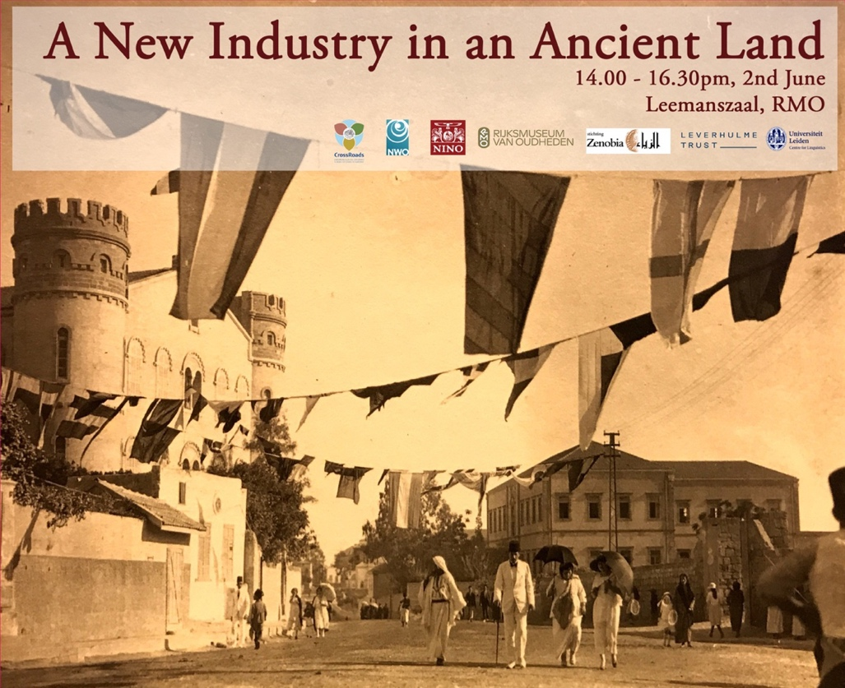

A New industry in an Ancient Land (NIAL) considers the vocabularies of tourism to think about the ways in which Palestine was both produced and consumed by both Arabs, Jews and Europeans. Archaeology, archaeologists and photography are central: they informed the tourism industry through the production of travel guides and tour manuals, photo books and postcards, and the framing of holy sites and biblical cartographies.
NIAL also considers the relationship between tourism and cultural diplomacy, and thus archaeology, which was central to such endeavours given the formation of the joint British, French and American Archaeological Advisory Board and the ways in which such cultural diplomacy shaped the presentation of archaeological materials. The Palestine Archaeological Museum, now the Rockefeller Museum in Jerusalem, stands testament to such processes.
NIAL will address how local cultural production may have formed as a response to Western scholarly interests in the region. Archaeology became increasingly entwined with Western diplomatic aspirations in the Levant, but also as part of the circuits of popular tourism. In this respect, the biblical overtones of ‘Holy Land’ tourism is both a product of modernity (especially the technological infrastructures that enabled it), but also a projection into an ancient past that undermines such modernity.

Part 1 Archaeology and Tourism
Panel with Jasmin Daam (U. Kassel), Felicity Cobbing (Palestine Exploration Fund), Sary Zananiri (Leiden University)

Sarah Irving and Sary Zananiri: ‘Iliffe’ John Henry Iliffe was the first Keeper of the Palestine Archaeological Museum. His partial diary leaves us an account of his movements and the negotiation of the 1948 war. Alongside this sits a significant collection of photographs of antiquities, conservation processes and archaeological digs as well as postcards and other collateral produced by the museum that he had preserved. This visual material tells the story of how an institution and individual navigated archaeological and heritage projects from an academic perspective, while also positioning its activities and collection for popular public consumption.

Part 2 ‘Dutch and the Middle East’
Photographic exhibition (RMO) Frank Scholten: Archaeology and Tourism in the ‘Holy Land’ (reprised viewing of RMO exhibition, 2nd April 2020- Mid-October 2020)
Willy Jansen (Radboud University), Jan de Hond (Rijksmuseum, tbc) & Karène Sanchez Summerer, ‘Holland in the Holy Land- The Holy Land in Holland: The Dutch initiative of the Holy Land Foundation 1903-1933’
Willy Jansen (Radboud University), ‘Constructing an imagined Holy Land in the Netherlands. How Piet Gerrits showed the cultures of the East to the Dutch’
In the early twentieth century the plan was taken up to recreate part of the Holy Land in the Netherlands, to enable the less fortunate Dutch Catholics to experience the pilgrimage to Palestine by visiting the Biblical Museum of the Holy Land Foundation in Nijmegen. In 1915 this museum opened its doors to the public. The multiple representations of the Holy Land that could be admired by the local tourists were designed by Piet Gerrits, an all-round artist and craftsman, who had gained his knowledge of Palestine when working for the Latin missions in the Middle East from 1906 to 1911. In this museum he reproduced, materialized, transmitted and transformed his personal experiences in Trans-Jordan and Palestine.
Willy Jansen will analyse Gerrits’s visualizations of the East in paintings, statues and architecture. she will illustrate three ways in which his experience-based knowledge informed his work: embodied knowledge, material heritage and religious coexistence. Next, she will show that these visualisations were not easily assimilated or copied in Europe, as his representations based on intimate knowledge of everyday life in the Levant clashed with dominant Catholic iconographic norms and the assumptions, dominant representations, and religious aims of other authorities involved. But while his visual narrative was hardly effective in changing Dutch perceptions of the Middle East, his artwork was re-appropriated by Jordanians to restore their damaged local cultural heritage and Christian identity.
Keywords: Imagined Palestine, art, religious tourism
Biography: Willy Jansen is Professor emerita of gender studies at Radboud University Nijmegen, the Netherlands. She did extensive anthropological fieldwork in the Middle East, North Africa and Southern Europe on gender, identity, sexuality, religion and education. Her books include three on religious tourism: Gender, Nation and Religion in European Pilgrimage. 2012; Moved by Mary. The Power of Pilgrimage in the Modern World. 2009; and Islamitische pelgrimstochten. 1991. Among her published articles relevant for this workshop, may be one on the preconditions for sites of religious tourism to flourish: ‘From Vision to Cult Site. A Comparative Perspective.’ Archives de Sciences Sociales des Religions, 55 (151) 2010: 71-90, or two others on sharing or constructing core symbols: ‘Shared Symbols. Muslims, Marian Pilgrimages and Gender.’ European Journal of Women’s Studies, 15 (3) 2008: 295-311; and ‘Visions of Mary in the Middle East. Gender and the Power of a Symbol.’ In: I.M. Okkenhaug & I. Flaskerud (eds) Gender, Religion and Change in the Middle East: Two Hundred Years of History. 2005: 137-154. On early women influencers of ideas on the Middle East, see: Jansen, W. (2000), Women Anthropologists in the Arab World. Recognizing the Pioneers. History and Anthropology 12 (1), 1-27.

A New Industry
Book presentation: The Lives and Deaths of Jubrail Dabdoub (Or How the Bethlehemites Discovered Amerika), Jacob Norris, Univ. Sussex; discussant: Cyrus Schayegh

‘The Multilingual Holy Land’
Friday 3/06/2022 14:30-16:30

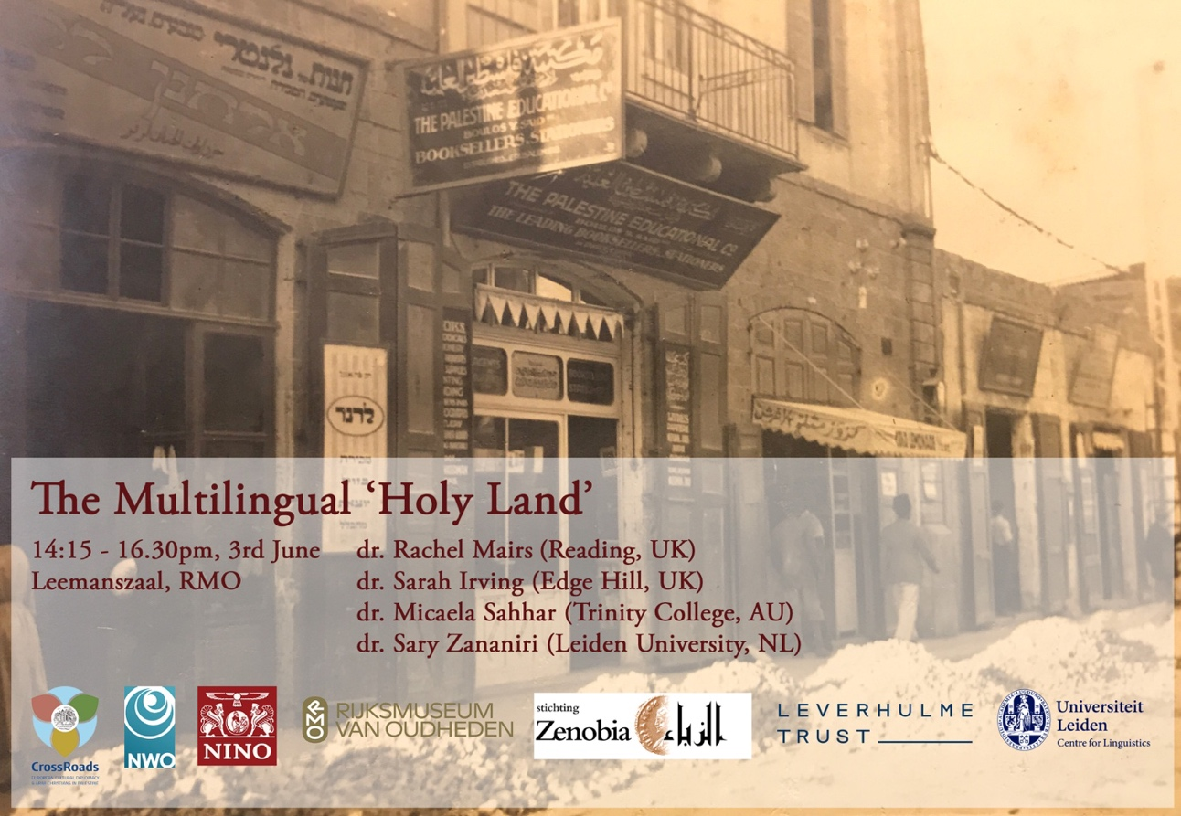

Rachel Mairs (UK) University of Reading
Colloquial Arabic manuals and archaeologists in Palestine and Egypt

Sary Zananiri, Sarah Irving, Karène Sanchez Summerer and Micaela Sahhar
The Multilingual Holy Land
Presentation of the four language editions of Frank Scholten’s Palestine Illustrated, George Antonius’ tourist guides and George Sahhar’s tourist guides

Photos exhibition at RMO

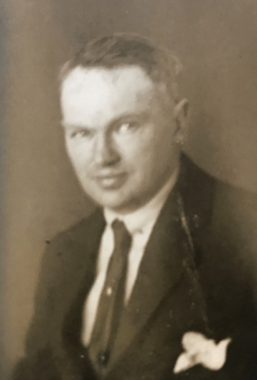
In early 1921, Dutch photographer Frank Scholten (1881-1942) arrived in the port of Jaffa in British Mandate Palestine. Over two years he took more than 20,000 photographs, mostly in Mandate Palestine, but also in Transjordan and French Mandate Syria and Lebanon.
Scholten shows us a world in which the ancient and modern intermingled. Archaeology was a significant theme, showing both the ancient sites and their modern histories. We see the impact of archaeology as an academic discpline, but also its popularisation through its relationship to tourism, especially in the antiquities and souvenir stores and the photographic studios that were both directly involved in documenting archaeological sites and in selling photos to tourists.
His images give us a rare glimpse into how modernity re-shaped Palestine through archaeology, the porosity between archaeological photography and popular imaging, which brought so much interest to the region, even for those who couldn’t visit in person. While the tourism industry had long existed, photography boosted public interest in archaeology, as we see from the growth of photobooks and travel guides.
Scholten’s approach to photography utilised the lens of the biblical, but did not shy away from exploring its relationship to modernity and the effects archaeology had on early Mandate society.

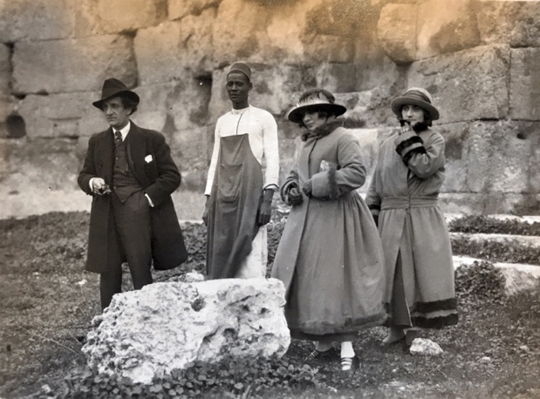
“Amwas” (Imwas or biblical Emmaus) c. 1921-23

Robert Curzon, Visits to Monasteries in the Levant (Cosimo, Inc., 2007).

